TOLLAND MIDDLE SCHOOL
FUNDRAISING INFORMATION

EIGHTH GRADE WASHINGTON, D.C., TRIP
November 2022

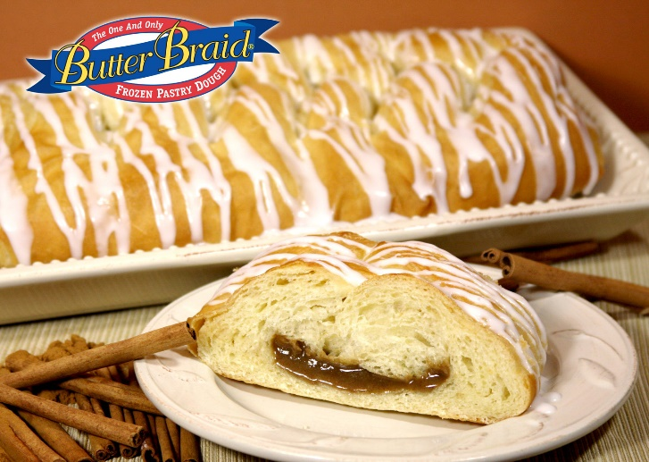

Our fundraiser will be Butter Braids and Cake Rolls!

The online site opens on March 30, 2022.
https://my.mcmfundraising.com/signup/KFH9

All orders are due by April 29, 2022.

Delivery will be on Wednesday, June 8, 2022.
Orders will be available in the café from 3:15-5:00 pm.

Your student will receive a 40% profit off his/her own trip total!

